


CELL CULTURE FLASKS
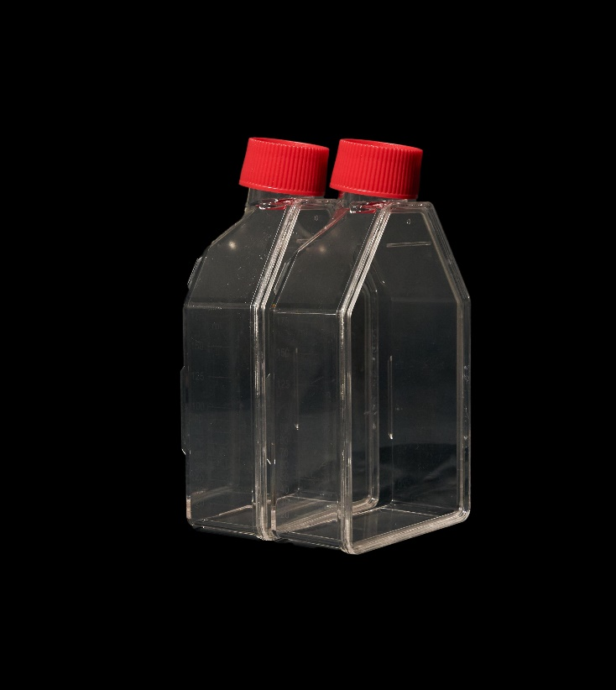
- Offered in growth areas of 25 cm², 75 cm², 175 cm², and 225 cm², enabling flexibility for scale-up and high-throughput applications
- E-beam or gamma sterilized to ensure a sterility assurance level of 10⁻⁶
- Vent cap options equipped with 0.22 µm filter membranes support effective gas exchange while reducing contamination risk
- Sealed cap variants provide a secure, leak-resistant closure to minimize evaporation and external contamination
- Frosted labeling zones with dual-side graduation markings for easy identification and volume tracking

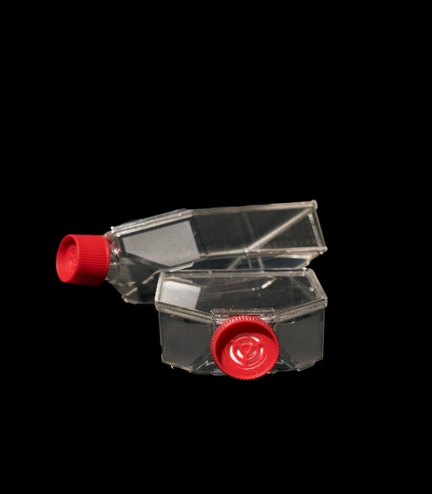

- Description:
Cell Culture Flasks are designed for the reliable cultivation of both adherent and suspension cell lines under controlled laboratory conditions. Manufactured from premium-grade, optically transparent polystyrene, these flasks deliver consistent performance and clarity for sensitive applications. The specially treated growth surface supports efficient cell attachment and proliferation, making them suitable for biopharmaceutical production, academic research, and regenerative medicine workflows.

- Quality & Safety Attributes
🔥 Non-Pyrogenic
Free from pyrogens to ensure safe and reliable cell culture performance
🧬 DNase- / RNase-Free
Manufactured to prevent enzymatic contamination that could compromise samples
🛡️ Non-Cytotoxic
Certified safe for cells, supporting healthy growth and viability

Technical Specifications
Cat. No. | Area | Working Volume | Cap Type | Max Volume (mL) | Sterile | Pack (pcs×bags)
PBL043V | 25 cm² | 5–7.5 mL | Vent | 50 | Yes | 12×25
PBL044V | 75 cm² | 15–22.5 mL | Vent | 175 | Yes | 5×18
PBL045V | 175 cm² | 35–52.5 mL | Vent | 550 | Yes | 5×10
PBL046V | 225 cm² | 45–67.5 mL | Vent | 800 | Yes | 5×10
PBL043NV | 25 cm² | 5–7.5 mL | Seal | 50 | Yes | 12×25
PBL044NV | 75 cm² | 15–22.5 mL | Seal | 175 | Yes | 5×18
PBL045NV | 175 cm² | 35–52.5 mL | Seal | 550 | Yes | 5×10
PBL046NV | 225 cm² | 45–67.5 mL | Seal | 800 | Yes | 5×10

Area = Cell growth area

Pack = pcs/bag × bags/carton


Discover More Products to Simplify Your
Laboratory Needs
Visit us at https://purplebiolabs.com/
03/26_00
For further queries, contact us at info@purplebiolabs.com/support@purplebiolabs.com


Prior to usage, users are responsible for ensuring the suitability of our products for their intended application. Our products adhere solely to the information provided in this and other related Purple Biolabs publications. The content in this publication is derived from our research and development efforts and is, to the best of our knowledge, accurate and reliable. Purple Biolabs retains the right to modify specifications and product-related information at any time. Our products are designed for laboratory and research purposes only, unless otherwise specified. The statements herein should not be construed as a warranty, whether expressed or implied, and we do not accept liability for any patent violations.

